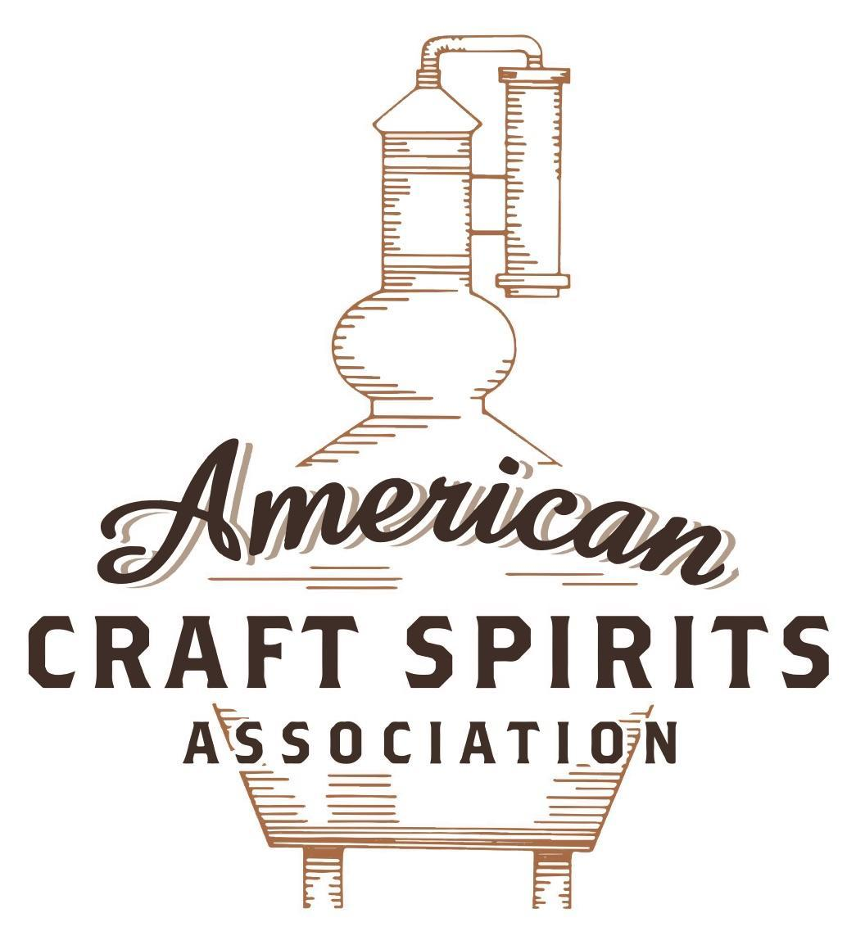
Spirits DtC Shipping Guide

This guide summarizes the direct-to-consumer shipping rules for distilleries in all 50 states and D.C. and also addresses the measures state governments have taken to ease delivery and shipping restrictions during the COVID-19 pandemic.

DtC Quick Guide Comparison

Out-of-State Distilleries  Can Ship Into State? |  |  |  | In-State Distilleries  Can Ship Within State?
State | Yes | No |  | State | Yes | No
AL |  | X |  | AL |  | X
AK | X |  |  | AK | X
AZ | X |  |  | AZ | X
AR |  | X |  | AR |  | X
CA |  | X* |  | CA |  | X*
CO |  | X |  | CO |  | X
CT |  | X* |  | CT |  | X
DE |  | X |  | DE |  | X
DC | X |  |  | DC | X
FL |  | X |  | FL |  | X
GA |  | X |  | GA |  | X
HI |  | X* |  | HI |  | ?*
ID |  | X |  | ID |  | X
IL |  | X* |  | IL |  | X*
IN |  | X |  | IN |  | X
IA |  | X* |  | IA |  | X*
KS |  | X |  | KS |  | X
KY | X |  |  | KY | X
LA |  | X |  | LA |  | X
ME |  | X* |  | ME |  | X*
MD |  | X |  | MD |  | X
MA |  | X |  | MA |  | X
MI |  | X |  | MI |  | X
MN |  | X |  | MN |  | X
MS |  | X |  | MS |  | X
MO |  | X |  | MO |  | X
MT |  | X |  | MT |  | X
NE | X |  |  | NE | X
NV |  | X* |  | NV |  | X
NH | X |  |  | NH |  | X*
NJ |  | X* |  | NJ |  | X*
NM |  | X |  | NM |  | X
NY |  | X* |  | NY |  | X*
NC |  | X |  | NC |  | X
ND | X |  |  | ND | X
OH |  | X |  | OH |  | X
OK |  | X |  | OK |  | X
OR |  | X |  | OR | X
PA |  | X* |  | PA |  | X
RI |  | X* |  | RI |  | X
SC |  | X |  | SC |  | X
SD |  | X |  | SD |  | X
TN |  | X |  | TN |  | X
TX |  | X |  | TX |  | X
UT |  | X |  | UT |  | X
VT |  | X |  | VT |  | X
VA |  | X |  | VA |  | X
WA |  | X* |  | WA | X
WV |  | X* |  | WV |  | X*

WI |  | X |  | WI |  | X
WY |  | X |  | WY |  | X

Notes:
*CA: If passed and signed into law, Senate Bill 620 would allow licensed distilled spirits producers in states other than California and licensed distilled spirits manufacturers or craft distillers in California who obtain distilled spirits direct shipper permits to ship directly to consumers in California
*CT: Consumers with appropriate permit may receive alcohol shipments
*HI: Consumers with appropriate permit may receive alcohol shipments; If passed and signed into law, Senate Bill 65 would allow licensed distilled spirits manufacturers in Hawaii and in states other than Hawaii who obtain direct shipper permits to ship directly to consumers in Hawaii
*IL: If passed and signed into law, Senate Bill 0532 would allow licensed distilled spirits producers in Illinois and in states other than Illinois who obtain distillery shippers’ licenses to ship directly to consumers in Illinois
*IA: If passed and signed into law, House File 639 would allow native distilled spirits manufacturers in Iowa and in states other than Iowa who obtain direct shipper permits to ship directly to consumers in Iowa and to consumers in states other than Iowa
*ME: If passed and signed into law, Legislative Document 1358 would allow distilleries outside of Maine with current manufacturer licenses and distilleries licensed in Maine who obtain spirits direct shipper licenses to ship directly to consumers in Maine
*NJ: (1) If passed and signed into law, Assembly Bill 3167 would allow a craft distillery licensees to ship no more than 9 liters of distilled spirits to a consumer in New Jersey; (2) If passed and signed into law, Senate Bill 3020 would allow craft distillery licensees in New Jersey or in states other than New Jersey to ship no more than 20 liters of distilled spirits to a consumer in New Jersey via common carrier
*NV: Licensed individuals can import one gallon per month of spirits for personal use and the out-of-state supplier must pay excise tax
*NH: If passed and signed into law, Senate Bill 125 would allow licensed liquor manufacturers who obtain direct to consumer shipping permits from the commission to ship directly to consumers in New Hampshire
*NY: Consumer may import up to 90L of liquor per year for personal use without a license; If passed and signed into law, Assembly Bill 3275 would allow licensed liquor manufacturers in states other than New York and licensed distillers and farm distillers in New York to ship no more than thirty-six cases (no more than nine liters per case) of liquor to consumers in New York
*PA: Consumer may place a special liquor order and distiller must ship to a PLCB-operated store
*RI: Distiller can only ship to customer if order was personally placed by customer at distiller's premises
*WA: If passed and signed into law, House Bill 1432 would allow licensed spirits manufacturers in states other than Washington to ship spirits to consumers in Washington
*WV: Distilleries, mini-distilleries, or micro-distilleries licensed in West Virginia or a state other than West Virginia who obtain private direct shipper licenses to ship to a consumer in West Virginia, however the shipments must be made to a retail liquor outlet

MISSISSIPPI

Shipment Outbound – Yes, if allowed by the purchaser’s applicable laws (Miss. Code Ann. § 67-1-51(1)(a)).

Shipment Inbound – No, all liquor must be sold to the Department of Revenue (Miss. Code Ann. § 67-1-45).

Shipment Intra-state – No, all liquor must either be sold to the Department of Revenue or at a manufacturer’s licensed premises with a distillery retailer’s permit (Miss. Code Ann. § 67-1-45; § 67-1-51(1)(q)).
COVID-19 Measures – The MI Department of Revenue amended the Administrative Code to allow customers to submit orders and pay liquor retailers by telephone or internet, and allow liquor retailers to provide on-premises curbside delivery during a state of emergency. This amendment, however, is limited to package retailers. H.B. 1135, signed and enacted into law on April 14, 2021, authorizes a holder of a package retailer’s permit, an on-premises retailer’s permit, or a beer, light wine and light spirit product permit to apply for a delivery service permit to deliver any alcoholic beverage, beer, light wine or light spirit product to a consumer who is at least 21 years of age in Mississippi no more than 30 miles from the retailer’s licensed premises. A delivery may be made by an employee of the holder of a delivery service permit or an independent contractor.
Link:
http://billstatus.ls.state.ms.us/documents/2021/html/HB/1100-1199/HB1135SG.htm
Citation (shipment)
Mississippi Code Annotated
§ 67-1-45. Selling alcoholic beverages to another source.
No manufacturer, rectifier or distiller of alcoholic beverages shall sell or attempt to sell any such alcoholic beverages, except malt liquor, within the State of Mississippi, except to the department, or as provided in Section 67-1-41, or pursuant to Section 67-1-51. A producer of native wine or native spirit may sell native wines or native spirits, respectively, to the department or to consumers at the location of the native winery or native distillery or its immediate vicinity.
Link: Miss. Code Ann. § 67-1-45
§ 67-1-51. Issuance of permit; distance restrictions; prohibition against multiple package retailer permits.
(1) Permits which may be issued by the department shall be as follows:
(a) Manufacturer’s permit. A manufacturer’s permit shall permit the manufacture, importation in bulk, bottling and storage of alcoholic liquor and its distribution and sale to manufacturers holding permits under this chapter in this state and to persons outside the state who are authorized by law to purchase the same, and to sell as provided by this chapter.
Manufacturer’s permits shall be of the following classes:
Class 1. Distiller’s and/or rectifier’s permit, which shall authorize the holder thereof to operate a distillery for the production of distilled spirits by distillation or redistillation and/or to operate a rectifying plant for the purifying, refining, mixing, blending, flavoring or reducing in proof of distilled spirits and alcohol.
(q) Distillery retailer’s permit. The holder of a Class 1 manufacturer’s permit may obtain a distillery retailer’s permit. A distillery retailer’s permit shall authorize the holder thereof to sell at retail alcoholic beverages to consumers for on-premises consumption, or to consumers by the sealed and unopened bottle from a retail location at the distillery for off-premises consumption. The holder may only sell product manufactured by the manufacturer at the distillery described in the permit. However, when selling to consumers for on-premises consumption, a holder of a distillery retailer’s permit may add other beverages, alcoholic or not, so long as the total volume of other beverage components containing alcohol does not exceed (20%). Hours of sale shall be the same as those authorized for on-premises permittees in the city or county in which the distillery retailer is located.
The holder shall not sell at retail more than ten percent (10%) of the alcoholic beverages produced annually at its distillery. The holder shall not make retail sales of more than two and twenty-five one-hundredths (2.25) liters, in the aggregate, of the alcoholic beverages produced at its distillery to any one (1) individual for consumption off the premises of the distillery within a twenty-four-hour period. The hours of sale shall be the same as those hours for package retailers under this chapter. The holder of a distillery retailer’s permit is not required to purchase the alcoholic beverages authorized to be sold by this paragraph from the department’s liquor distribution warehouse; however, if the holder does not purchase the alcoholic beverages from the department’s liquor distribution warehouse, the holder shall pay to the department all taxes, fees and surcharges on the alcoholic beverages that are imposed upon the sale of alcoholic beverages shipped by the Alcoholic Beverage Control Division of the Department of Revenue. In addition to alcoholic beverages, the holder of a distillery retailer’s permit may sell at retail promotional products from the same retail location, including shirts, hats, glasses, and other promotional products customarily sold by alcoholic beverage manufacturers.
Link: Miss. Code Ann. § 67-1-51

The American Craft Spirits Association (ACSA) is working diligently to give our members and industry partners relevant, current updates on statutes and regulations impacting production, sale and distribution of spirits. With the declaration of the novel coronavirus (COVID-19) in early 2020, many states have issued temporary policy changes or longer-term modernization of alcohol beverage laws. State statutes, regulations created by the state alcohol regulatory authority, as well as any other relevant guidance provided by such authorities (such as advisories, opinions, bulletins, etc.) were reviewed in creation of this document. No city or county ordinances were reviewed. Distillers should be aware that even in states where direct shipping is permissible, always remember to avoid shipping to dry counties. Please consult with your state guild or alcohol beverage authority for the most up-to-date information. This content is intended for educational and informational purposes only. ACSA's pro bono law firm of Malkin Law P.A. provided the core content found in this comprehensive overview of the spirits distribution after COVID-19. It was completed in August 2021 and will be updated regularly. If you have updates you would like to provide, please send to legislation@americancraftspirits.org or directly to the law firm at: ryan@malkin.law / malkin.law. Thank you.

